Training – Merge Analysis Module

Document Version: v1.0
Date: 22nd September 2020

This document provides initial training on the Merge Analysis function within clearMDM .This document does not go into technical detail and is intended to compliment other clearMDM training modules. It would be beneficial to have gone through some of the other Training Modules to understand the Attribute Group and Merge Process.

Table of Contents
Training – Merge Analysis Module 1
Merge Analysis Introduction 2
Step 1 – Merge Analysis Settings 2
Step 2 – Attribute Group setup 3
Step 3 – Create two new Records 3
Step 4 – Run the BKPR 4
Step 5 – Viewing the Merge Analysis Page 4

Merge Analysis Introduction

Merge Analysis provides a recent history of updates made during the Merge process, for Attribute Groups only. (Please refer to the Attribute Groups training module for further information).

The page itself is only available on the Master Record where it is most relevant. The option to view on the Merge Source Record is available, but a message will be displayed explaining this is not the Master Record.

Step 1 – Merge Analysis Settings

The first step is to setup the Merge Analysis settings within clearMDM.

- Within clearMDM navigate to Settings.
- Click on Target Objects.
- Select the Target Object in question.
- In the Merge Settings section, ensure the following settings are set:

Is Attribute Group Only? = Ticked
Master Field Map Field Name = System Master Field Map

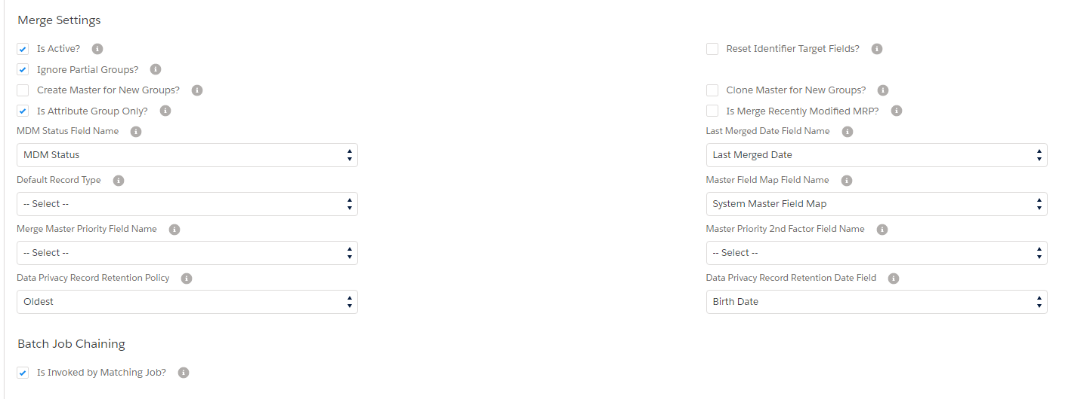

Step 2 – Attribute Group setup

The Merge Analysis relates to Attribute Groups only, so an Attribute Group will need setting up.

- Within clearMDM navigate to Settings.
- Click on Attribute Groups tab.
- Within here setup an Attribute Group for the Target Object in question.

Note: As a reminder on how to do this, please refer to the Attribute Groups Training Module.

Step 3 – Create two new Records

- Within Salesforce create two new records.
- Use the Blocking Key that is relevant to the Target Object under question.

Note: If you go to Settings and the Target Objects tab, if you edit the Target Object you will see in the Blocking Key Structure section what needs to be populated to create the Blocking Key.

- Enter details into the fields that make up the Attribute Group.
- Ensure the checkboxes ‘Is Active for Matching?’ and ‘Is Active for Reparenting?’ are set.

Step 4 – Run the BKPR

- Navigate to the Blocking Key Process Request Tab.
- Create new or clone an existing one.
- Make sure the correct Target Object is set.
- Enter the Blocking Key for the two records.
- Set to new and wait until the status shows as reparented.

Step 5 – Viewing the Merge Analysis Page

- Navigate to the Records created in Step 3.
- Identify which one is the Master Record (this will be determined within the record itself).
- Click on the Merge Analysis link from the arrow dropdown (Lightning), or the Merge Analysis button (Classic).
- The Merge Analysis page will be displayed. This will show the record the fields identified in the Attrinute Group have been updated from.

