Training – Setting up multiple Target Objects per Salesforce Object Module

Document Version: v1.0
Date: 28th February 2020

This document will provide initial training for the setup of multiple target objects referencing the same Salesforce Object. This document does not explain the technical aspect or discuss the other functions within clearMDM. More detailed technical information can be found in the quick start guides located here clearMDM.com

Table of Contents
Training – Setting up multiple Target Objects per Salesforce Object Module 1
Multiple Target Objects referencing the same Salesforce Object 2
Use Case 1 – Adding the settings within clearMDM 2
Use Case 2 – Setup the Data Source Settings for the Target Object 4
Use Case 3 – Test the correct Blocking Key is produced for the Record Type 5

Multiple Target Objects referencing the same Salesforce Object

Introduction

If you have a Target Object which has more than one record type, for example, in Accounts you may have Customers and Suppliers, when creating a Master Record, you may not want to match and merge the record types together.

By setting up a separate Target Object per record type you can specify a different Blocking Key for each one so that when the jobs are run, the records will not be matched and merged as the Blocking Key will not be the same.

What this also means is that you can setup Attribute Groups (merge rules) for individual record types if you do not want the same merge rules to apply, or you can apply to all record types if you wish.

To do this, follow the steps below:

Use Case 1 – Adding the settings within clearMDM

This example is based upon SObject Type Accounts having a specific record type of Supplier.

- Navigate to Settings within clearMDM.
- Click on Add.
- Enter a name for the Target Object – in this example Supplier RT.
- Select the SObject Type – Accounts.
- At this point, the Record Type field will be enabled if you have more than one record type active for this SObject.
- Click the ‘Is Active’ checkbox for Normalisation Settings.
- Complete the settings as per the requirement for the Blocking Key. In this example we are going to use the Account Name:

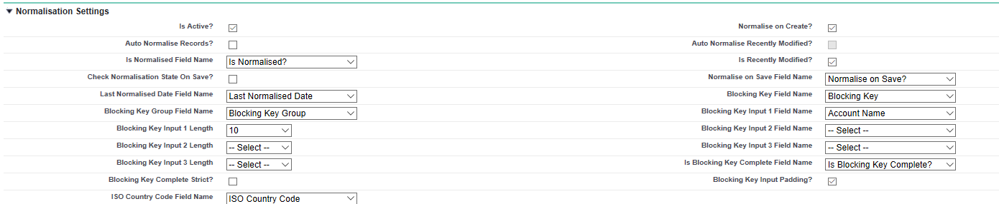

- Complete the remaining settings as per the required setup.
- Ensure the correct Record Type is selected in the Merge Settings and Conversion Settings (Default Record Type field).
- Click on save.

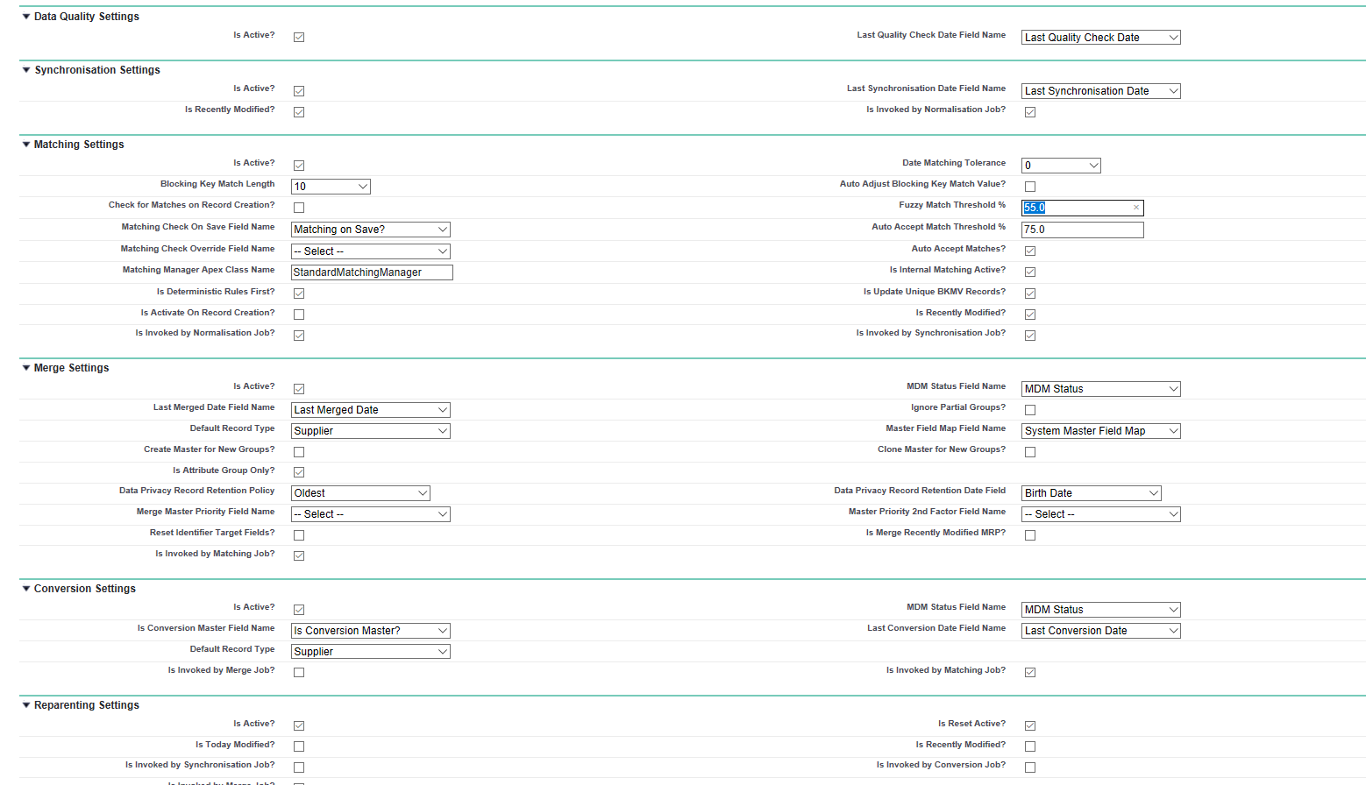

Note: Once the Target Object is setup, you cannot edit the Name, SObject Type or Record Type fields. If any of these fields need amending you will need to delete the Target Object and re-input.

Use Case 2 – Setup the Data Source Settings for the Target Object

Once the Target Object has been setup, the Data Source will need setting up for that Target SObject Type.

- Navigate to Settings within clearMDM.
- Click on the Data Sources tab.
- Click on Add Data Source.
- Select the ‘Is Active’ checkbox.
- Enter a name, in this example ‘Suppliers’.
- Click on the Target SObject Type dropdown and you will see the Target Object created in use case one.
- Select this and complete the remaining settings as required.

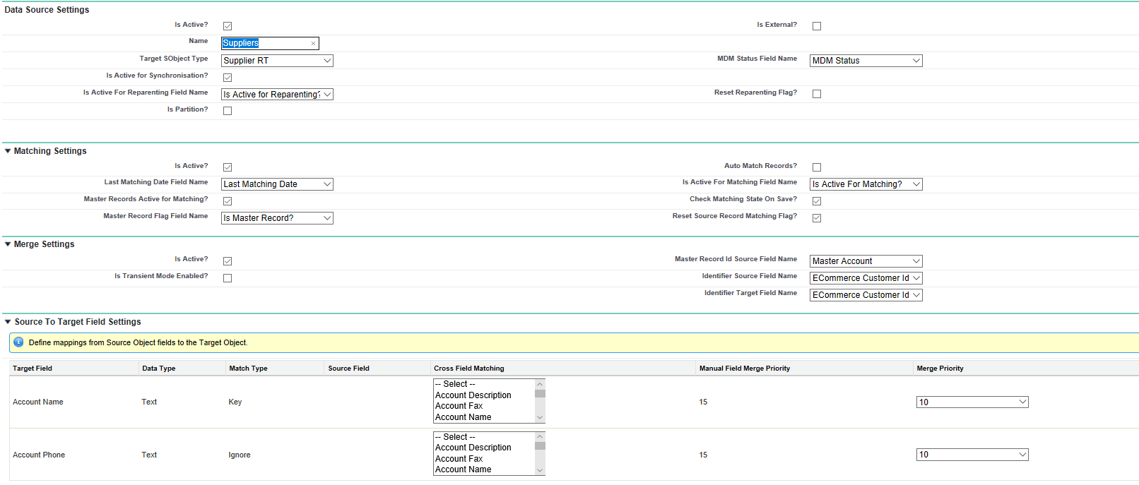
- Click on save.
- The Data Source settings have been setup.

Use Case 3 – Test the correct Blocking Key is produced for the Record Type

- Navigate to Accounts in Salesforce.
- Click on New.
- Select the Record Type Supplier (in this example).
- Enter the Supplier details.
- Click on save.

In this example the Blocking Key is the Account Name which has been correctly produced:

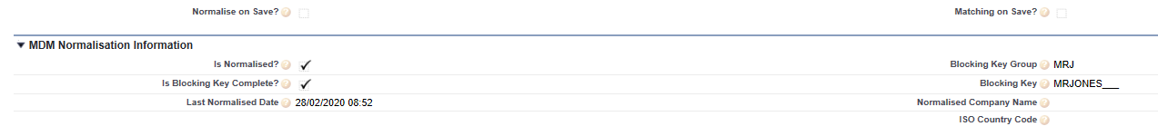
If you want to use a different Blocking Key for any other record types within the SObject Type Account, then you create the Target Object and leave the Record Type blank. So, in our example, we have a Blocking Key of Account Phone for any other record types.

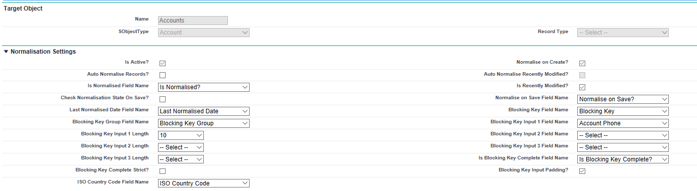
Creating a new record within Accounts which is not a Supplier will create the correct Blocking Key:

In this example, the phone has been used:

This means when the matching, merging jobs are run, the two records that have been created will not be matched as the Blocking Key is different.

